BRIEF REPORT ON AN ORANGE DISEASE DETECTION MODEL

System Architecture, Dataset Engineering, and Performance Evaluation Report

Summary
This report details the end-to-end engineering lifecycle of an automated edge-deployable citrus pathology detection system. Built using a data-centric AI approach, the system is designed to identify four distinct categories from localized fruit profile imagery: Citrus Greening (Huanglongbing), Citrus Canker, Melanose, and Fresh (Healthy) Fruit.
The primary engineering challenge resolved during this cycle was domain-shift mitigation. Initial versions of the model scored highly on clean validation splits but failed under field conditions because standard color/contrast adjustments distorted the precise biological markings of the target pathogens. By enforcing strict data-integrity constraints at the preprocessing layer and utilizing a cutting-edge, end-to-end, NMS-free architecture (YOLO26s), the system achieved a high overall mean Average Precision mAP50 of 88.7%.

Preprocessing Specifications
- Auto-Orient: Applied to strip orientation metadata from varying mobile sensor baselines.
- Resizing (Fit / Black Edges) to 640x640 pixels: To maintain the exact spatial aspect ratio of circular fruits. Standard stretching operations distort circular pathologies into ellipses, which corrupts the regression layer's training data. Letterboxing with black padding preserves true structural dimensions.

The Invariance Augmentation Matrix (3x Multiplication)
To ensure the model functions reliably when a farmer handles a smartphone camera under dense canopy shade, all color-distorting configurations were completely disabled. Only safe geometric transformations were applied:
- Horizontal Flip: Simulates alternative viewing angles across the tree branch structure without shifting color wavelengths.
- 90° Rotate (Clockwise, Counter-Clockwise, Upside Down): Multiplies sample volume 4x to remove rotational bias. This teaches the model to isolate lesion profiles regardless of branch sag or camera inversion.
- Rotation: Decouples the bounding box regression head from fixed vertical and horizontal grid lines, building resilience against tilted hand positions.
- Crop (0% Minimum, 10% Maximum Zoom): Simulates focal distance variances, forcing the network to recognize lesions from distances ranging from 15cm to 50cm.
- Blur (Up to 1.5px Gaussian Blur): Intentionally deconstructs high-frequency pixel perfection to simulate micro-hand tremors and slow shutter speeds common in shadowed orchards. This forces the convolutional layers to rely on macro-shapes rather than edge sharpness.

Banned Filters (Data-Integrity Safeguard)
- Disabled: Hue, Saturation, Exposure, Contrast, and Grayscale.
- Justification: Plant pathology depends heavily on specific color vectors. Shifting Hue completely breaks the chlorophyll loss mapping needed for Citrus Greening. Adjusting Saturation or Contrast artificially exaggerates normal skin pores, converting them into dark, high-contrast false positives that the model confuses with Canker halos.

Model Architecture & Training Configuration
The project utilized the YOLO26s (Small) model family, an advanced edge-first framework optimized for resource-constrained targets.

Architectural Blueprint
- Layers: 122 Layers (Fused)
- Parameter Volume: 9,466,728 Parameters (Fully trained)
- Compute Footprint: 20.5 GFLOPs
- Core Innovations: YOLO26s operates as a native end-to-end, NMS-free architecture. By removing the traditional Non-Maximum Suppression post-processing step and utilizing a one-to-one dual label assignment mechanism, it decreases CPU latency significantly. Additionally, it removes Distribution Focal Loss (DFL) to ensure clean deployment exports for edge microcomputers.

Training Configuration Script (Executed on Kaggle Dual T4 GPU Tensor Cores)
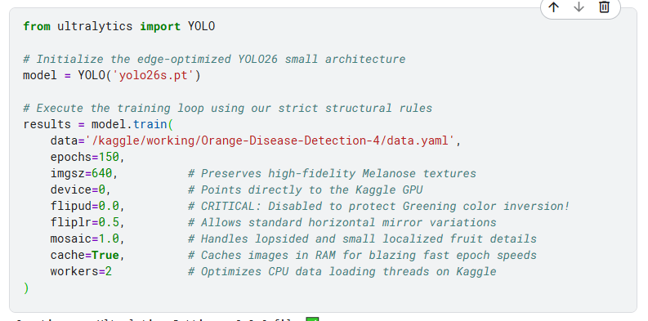

Empirical Results & Performance Discussion
Following a full 150-epoch cycle, the validation phase evaluated 133 images containing 206 distinct pathological and healthy targets.

Performance Breakdown Matrix
Target Class | Evaluated Instances | Precision (P) | Recall (R) | mAP50​ | mAP50−95​
🟠 Citrus Greening | 40 | 99.9% | 95.0% | 99.1% | 93.8%
🍏 Fresh (Healthy) | 36 | 83.3% | 94.4% | 95.6% | 92.5%
🟡 Melanose | 37 | 86.9% | 73.0% | 75.7% | 68.0%
🔴 Citrus Canker | 93 | 82.7% | 67.0% | 84.3% | 51.2%
📊 System-Wide Mean | 206 | 88.2% | 82.4% | 88.7% | 76.4%

Evaluation Analysis
- The Citrus Greening Triumph: Achieving a 99.1% mAP50 confirms that protecting the raw color gradients from synthetic modifications allowed the network to map the true biological phenotype of the disease with near-perfect classification accuracy.
- The Canker Localization Bottleneck: While the model effectively flags general Canker regions (mAP50 of 84.3%), the strict localization score (mAP 50-95) drops to 51.2%. This behavior is directly tied to feature density: the dataset contains 93 instances packed into only 30 images. This high concentration of tiny, overlapping scabs challenges the coordinate regression head of a lightweight edge model, leading to broader, clustered bounding boxes instead of individual, tightly fitting borders.
- Melanose Resolution Boundaries: The moderate recall (73.0%) reflects the physical nature of Melanose, which manifests as microscopic, sand-paper-like spots. On a 640x640 canvas, these patterns span only a few pixels, testing the limits of a small parameter backbone.

Software Realization & Deployment Interface
To translate these network weights into a functional utility, a web interface was engineered using Streamlit. The interface runs pure model inference directly on uploaded images with no additional runtime modifications.

[User Image Upload] ──► [Model Predict API with Slider Confidence Score] ──► [Conditional State Logic Printout]
The application provides a dynamic slider enabling real-time adjustments to the confidence score threshold. To prevent user confusion, the backend maps predictions directly to user-friendly status indicators. If the threshold filters out all tentative bounding boxes, the system gracefully triggers a clear notification stating: "The model could not identify any disease or healthy fruit signatures at this confidence level."

